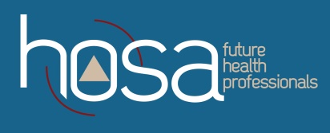
New York
New York State HOSA Membership Application

Welcome to HOSA! In order to complete your membership application, you need to complete this form:

First Name |  |  |  |  |  |  | Last Name
Home Contact Information
Street Address
City |  |  |  |  |  | State |  |  |  |  | Zip Code
Phone Number
Email address
Grade |  |  | Gender (Male, Female, Other) |  |  |  |  |  | Race (Asian, Black, Latino, Native American, White, Other)
School Name
School Address street
City |  |  |  |  | State |  |  |  |  | Zip Code
Advisor’s Name
Advisor’s email
Chapter # (if known)

This form can be sent by:
1.E-mail: StateAdvisor@newyorkhosa.org

2. Mail: Theresa Mitchell, New York State HOSA
State Advisor
4162 South Street Road
Marcellus, NY 13108

Dues for 2020-2021 are $22.00 – Make checks/money orders payable to HOSA – Future Health Professionals
Include your name, Chapter # in the “memo” of the check

